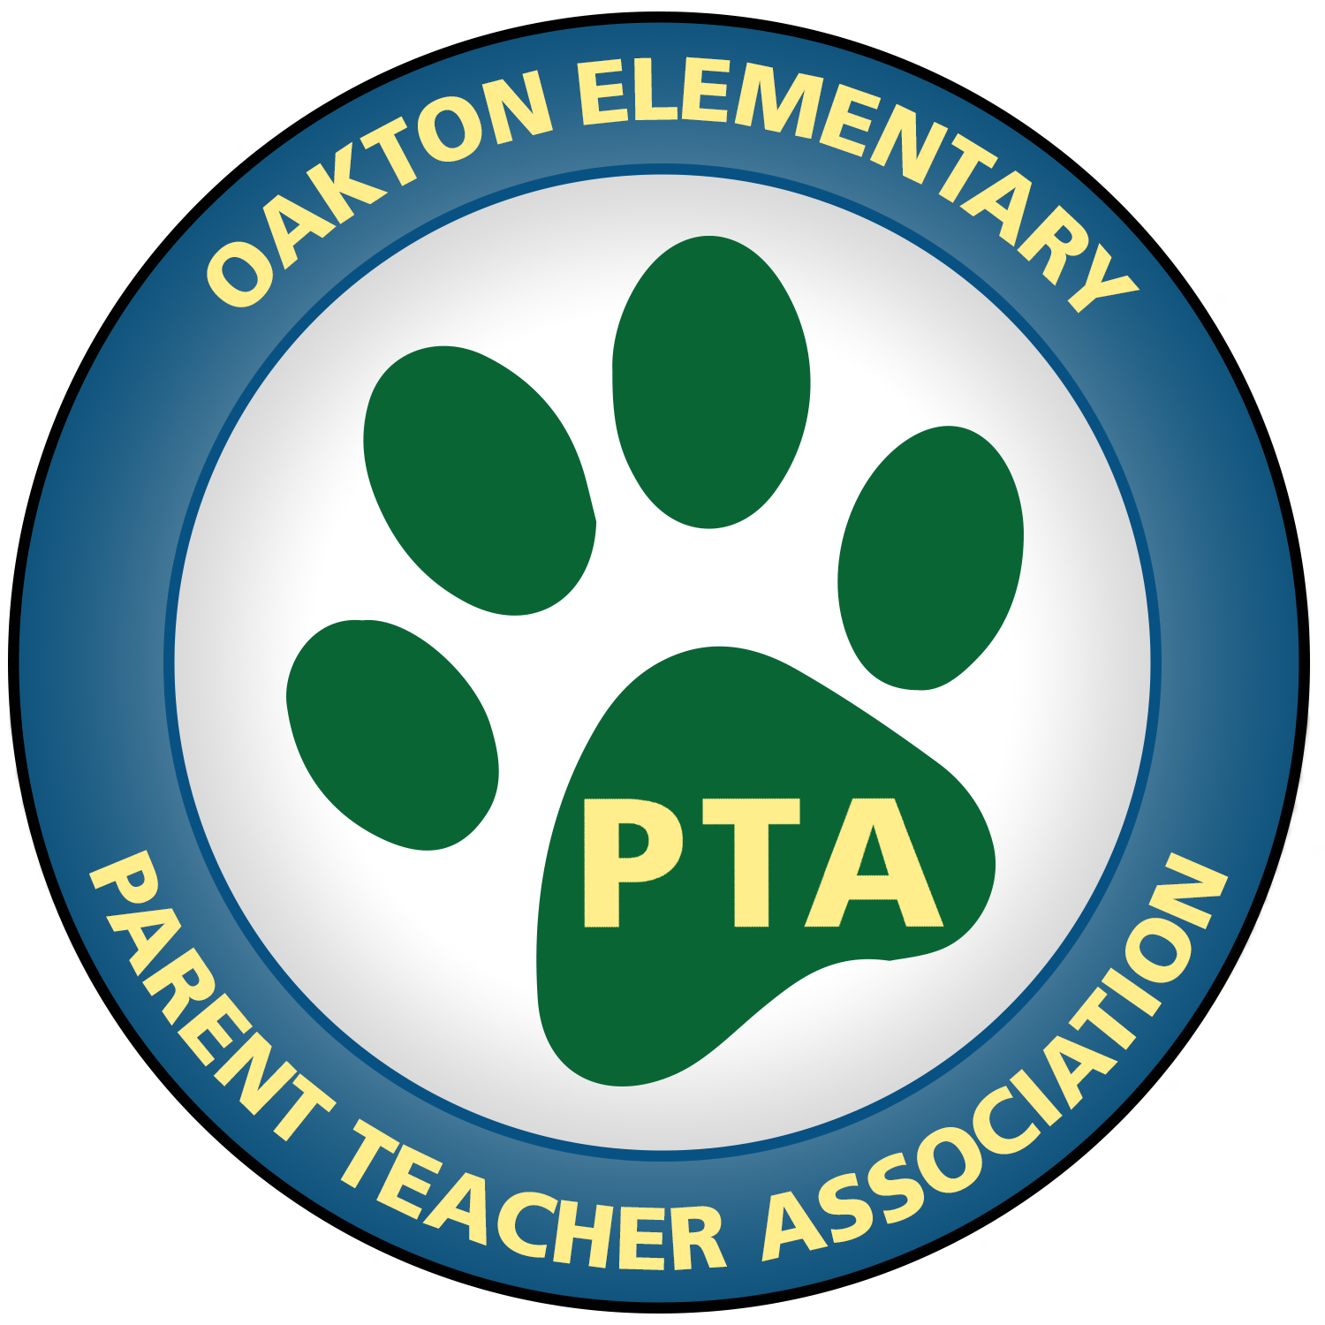
Minutes
OES PTA Meeting
September 4, 2019, 8:30 am

In Attendance
Chris Kelly, Keith Eck, Karen Rose, Brigette Polmar, Mimi Chou, Ellie Zadeh, Meredith Campbell, Jen Maki, Gary Korolev, Nicole White, Joanie Dugan, Donna Karkarala, Corin Harmon, Jim Miller, Kathleen Tobin, Patty Rop, Paula Currall, Zuzana Dawson, Rachel Sitta, Kristen McBrayer, Matthew Stewart, Courtney Chadwick

Welcome
Karen Rose, PTA President, welcomed everyone.
First meeting as President! It is going to be a great year!

Approvals from Prior Year
Minutes
Karen Rose made a motion that the miutes from the prior year’s meetings be approved. It wa s seconded by Brigette Polmar and approved (unopposed).

Budget / Audit
The audit of last year’s books was conducted in August by Karen Rose, Meredith Campbell, Gary Korolev, and Donna Kakarala. Karen reviewd highlights. A copy of the audit is available upon request. Ellie made a motion to approve the audit, seconded by Donna Kakarala, the audit was unanimously approved.

QUESTION: Jim Miller asked about the credit card fees. Karen Rose and Brigette Polmar explained that this amount is comprised of transaction fees that are incurred when accepting credit card payments. This is a reason the PTA always encourages that people pay cash for things (like ticket sales, spirit wear, etc). Nicole White further explained that the boost in the volume of sales resulting from our ability to accept credit card payments far ourweighs the fees incurred for doing so. The PTA will still encourage cash sales going forward, but will accept credit card payments when possible.

A motion to approve the previous year’s numbers was made by Karen, seconded by Jim Miller, and unanimously approved.

Current School Year Business
Current Budget
The budget for the current school year was handed out and reviewed. One highlight is the return of the Art Show this year.
Karen Rose also explained in some detail the reason behind new purchases of equipment for video production to be made for the PTV crew. She explained what PTV is, what it means to the school, and also what the PTV experience is all about. Karen enumerated benefits and learning in that experience. Mr. Stewart explained that he worked with a county tech specialist to review needs and a list of recommendations resulted. Fortunately the school is wired, so the most expensive options are not necessary at this point. The equipment request is for a low-end sound mixer and a camcorder, for a total of about $3k.

Karen Rose made a motion to approve the budget, Brigette Polmar seconded, it was approved unanimously.

Brigette Polmar thanked Mr Stewart and PTV for all it does to support the PTA. The mention of an event or news on PTV is very effective and generates great responses and interest – more than the PTA could ever do on its own. The PTA appreciates the help of PTV and is happy to support PTV. It’s just great!

Fundraising
Spirit Wear
Items are available for sale and can be purchased online (credit card) and also via order form (cash or check). Flyers will go home in Tuesday folders next week. Sale continues through September 27th. Some items were available at open house and sold well, showing interest in spirit wear.

Movie Night
While there is no formal chair, the PTA is moving ahead with this event. The movie selection will be made by student vote this year to generate even more enthusiasm for the event.
*After the meeting, Kristen McBrayer volunteered to help with food for movie night. She has an awesome idea about pre-ordering pizza that could be a game changer.

Raise Craze - October Fundraising
Jen Maki explained that the fundraiser is a Kindness Campaign. It’s an event that challenges kids to do positive things which goes along great with the school’s Positivity Project.
During the fundraiser, students pay it forward by completing Acts of Kindness for others, i.e. collecting can goods or toiletries, writing thank you's to first responders in our community, to helping a friend that's having a bad day. All acts of kindness are encouraged and recognized!
The program is customizable for the school and for each student who decides which positive actions he/she will take. These actions can impact the school and/or the community. Positive actions earn money for the school!
Panther Pride Envelopes
Donations from families who can contribute. No associated event, activity, schedule or voluteers necessary. These will go out in October.

Corporate Sponsors
Rupa is working hard to find corporate sponsors for OES and has already had some success. Karen Rose explained that there are different sponsorship packages for different levels of support, including the option to sponsor events. This is a great way to get local business excited about and involved in our school.

PTA Membership
Karen Rose encouraged all to become members of the PTA. Join!

Other Planned Events and Activities
Panther Art
Karen reminded everyone about the opportunity to participate in the school’s art program and encouraged people to sign up.

Read-In and Pumpkin Festival
Both fun events will coincide this year as the Read-In is planned for October 29th. Many pumpkins will already have been decorated and will be on display!

Halloween BINGO Night
Patty Rop volunteered to be Chair of this event. Applause and Cheers! Patty will wotk with others who have been involved in this event in the past. Patty has also offered to document the event specifics and it’s requirements for future use/reference.

Girls on the Run (GotR)
We are still awaiting approval for this program to go forward. We have one coach so far, but need another. We also need a chair of this activity. The chair holder will not have to physically run with the group as duties are administrative in nature.

Puzzle Night and Art Show
These two events will be on the same night, January 10th. Families can view student art and purchase their child’s framed masterpiece, and students can work/compete in teams putting puzzles together.

International Night
This event to be held February 7th. Need a co-chair. Jim Miller volunteered to co-chair the event. More cheers and applause!

Dining for Dollars
The first event of the year (at California Tortilla) was a success and lots of fun for families. There will be another event on September 24th at Panera from 4-8pm.

Karen Rose made a motion to adjourn the meeting. It was seconded by Gary Korolev and unanimously approved.

Next Meeting
The next Meeting will be on November 6th at 7pm in the OES library.

